Scenario 1: Manufacturing Quality Inspection (10 Marks)
(a) Interpret the scenario and identify the type of noise present.
The manufacturing quality inspection system captures images of metal components to detect defects such as cracks, scratches, or dents. Due to electrical interference during image acquisition, repetitive horizontal stripes appear across the images. This type of degradation is known as periodic noise because it occurs at regular intervals and follows a repetitive pattern. Periodic noise usually originates from electrical equipment, power supply interference, or electronic sensors used in the imaging system.

(b) Explain how this degradation affects inspection accuracy.
Periodic noise significantly reduces image quality by covering important surface details of the metal components. It decreases image contrast and makes small defects difficult to identify. Automated defect detection algorithms may incorrectly classify good components as defective or fail to detect actual defects. This leads to false positives and false negatives, reducing the overall reliability, efficiency, and accuracy of the quality inspection process.

(c) Recommend an appropriate enhancement technique to remove the interference.
The most suitable enhancement technique is Frequency Domain Image Enhancement using the Fourier Transform (FT) followed by a Notch Filter. The Fourier Transform converts the image from the spatial domain into the frequency domain, where periodic noise appears as distinct high-energy peaks. A notch filter is then applied to suppress these unwanted frequency components. Finally, the Inverse Fourier Transform (IFT) reconstructs the enhanced image with the periodic noise removed.

(d) Justify why your selected approach is more suitable than spatial-domain methods.
Frequency-domain filtering is more effective because periodic noise has specific frequency characteristics that can be easily identified and removed. The notch filter selectively removes only the unwanted frequency components while preserving useful image information. In contrast, spatial-domain filters such as mean or Gaussian filters process the entire image uniformly, which often results in blurred edges and loss of fine details. Therefore, frequency-domain filtering provides better image quality and more accurate defect detection.

(e) Explain your answer in a logical sequence.
- Capture the image of the metal component.
- Observe the presence of repetitive horizontal stripe noise.
- Apply the Fourier Transform to convert the image into the frequency domain.
- Identify the frequency peaks corresponding to the periodic noise.
- Apply a notch filter to remove those unwanted frequencies.
- Perform the Inverse Fourier Transform to reconstruct the image.
- Obtain a clear image with preserved details for accurate defect detection and quality inspection.
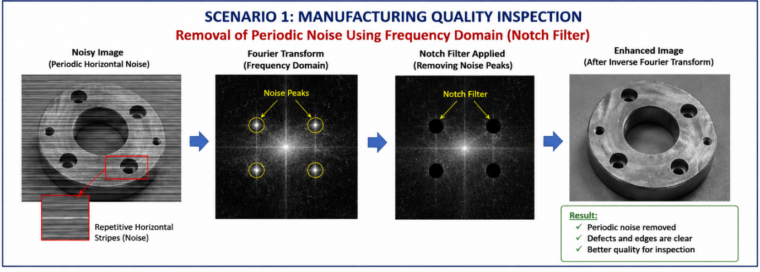

Scenario 2: Autonomous Vehicle Navigation (10 Marks)
(a) Interpret the scenario and explain the challenge involved.
A self-driving car captures road images during heavy rainfall. Rain introduces noise into the captured images, reducing visibility and image clarity. However, lane markings, road boundaries, pedestrians, traffic signs, and obstacles must remain clearly visible for safe navigation. The main challenge is to remove the noise while preserving these important image features, especially the edges.

(b) Identify the importance of preserving edges while removing noise.
Edges represent significant features in an image, including lane markings, road boundaries, vehicles, pedestrians, and traffic signs. Preserving these edges is essential because autonomous vehicles rely on them for lane detection, obstacle recognition, path planning, and safe driving decisions. If the edges become blurred during noise removal, the vehicle may fail to identify important objects, increasing the risk of navigation errors and accidents.

(c) Recommend a suitable filtering technique.
The most suitable filtering technique is the Bilateral Filter. It is an edge-preserving smoothing filter that effectively reduces image noise while maintaining sharp edges and important structural information.

(d) Justify why your selected filter preserves important image details.
The bilateral filter considers both the spatial distance between neighbouring pixels and the difference in their intensity values. Pixels that are close together and have similar intensities are averaged, while pixels across edges are not mixed. This allows the filter to remove noise without blurring object boundaries. Compared to Gaussian or mean filters, the bilateral filter provides better edge preservation, making it highly suitable for autonomous vehicle applications.

(e) Present your explanation clearly and systematically.
- Capture the noisy road image during heavy rain.
- Detect the presence of rain-induced image noise.
- Apply a bilateral filter to smooth the noisy regions.
- Preserve important edges such as lane markings and road boundaries.
- Use the enhanced image for accurate lane detection, obstacle recognition, and vehicle navigation.
- Enable the autonomous vehicle to make safe and reliable driving decisions based on the enhanced image.
